CONG THANH NGO

SWINBurne university  COS10004

LAB 05

**2. The first stage of Assignment 1:**

2.1. Designing a MOD counter for minute’s section, I would use:

+ 2 power/button

+ 1 clock

+ 7 LED

+ 7 J-K Flip Flop

+ 2 Hex Digit Display

+ 6 AND Gates

2.2. Resource:

+ Lecture slide week 3 for MOD counter

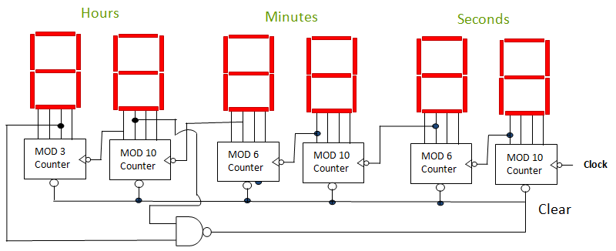+ <http://jessicasiboro.blogspot.com/2019/08/e-starc-stopwatch-timer-alarm-clock-for.html?m=0> for clock’s counter design

2.3. Logic circuit for 1st Stage:

